Follow these steps to create complex shift types (e.g. Term-time only patterns that span a 52 week period) or to upload multiple shift types in bulk when on-boarding new departments with a large number of new part-time shifts.

For individual shifts which repeat weekly, please see the separate guidance on Creating Shift Types

Contents
1. Complex shift types 1
2. Multiple shifts 3
3. Uploading the data file 5
4. Naming convention for complex shifts 7

Knowledge Article: WFM_Time Management Knowledge Article

Other Related documents
HOW TO - Prepare data for data migration
Part Time Shift Type Descriptions Calculator
Multiple shift generator tool
Rotating shift pattern builder spreadsheet.

Complex shift types
The Department should provide the employees' pattern using the 'Rotating shift pattern builder' spreadsheet.

  - Check that the spreadsheet has been correctly completed. All days within the sequence should have an entry, even if it is ‘Non-Working Day’.
*Review column J to check for errors.

  - Right-click on the worksheet tab and select ‘Unhide’

  - Unhide the ‘Data’ worksheet

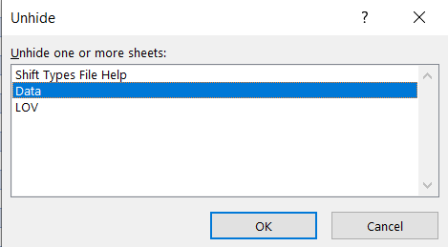

  - Within the Data tab, complete the Shift Type Code and Shift Type Description (see section on Naming convention for complex shifts)

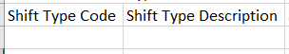

  - Check the 'Length' column for any descriptions which have more than 40 characters. These will need to be manually adjusted to within the 40 character limit.

  - This list can then be used to compare the ‘data’ worksheet to the original shift collection spreadsheet by creating a VLOOKUP based on the Shift Type Description column.

  - Right-click on the worksheet tab and select ‘Move or Copy’

  - In the ‘To book’ field select ‘(new book)’

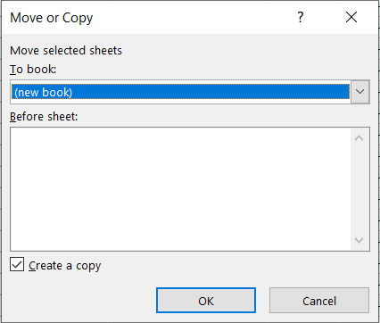

  - Within the new book, remove the formulas by selecting all the data, copying and then pasting the data back as values.

  - Check the shift code(s) does not already exist before attempting to load the data. Delete any shifts that already exist in the system from the working copy.

 | NB1: To check which shifts exist in the system, you can run the “Core Time Shift Type Reference Data List.sql” held in the Functional Analyst SQL Library.  NB2: If a department has reported all of their shifts and hasn’t checked if these already exist in the system, it is possible to load the shifts and allow the duplicates to error.

  - If the example record, Joe Bloggs, has been left in the sheet, remove the row.

  - Remove any blank rows

  - Remove any duplicate records

Multiple shifts
The Department should provide the employees' pattern using the 'Multiple shift generator tool'.

  - Check that the spreadsheet has been correctly completed. All days within the sequence should have an entry, even if it is ‘Non-Working Day’.
Review columns BV to BZ to check for errors.

  - Right-click on the worksheet tab and select ‘Unhide’

  - Unhide the ‘Data’ worksheet



  - Within the Data tab, complete the Shift Type Code (if applicable) and Shift Type Description (see section on Naming convention for complex shifts)

 | NB: When uploading multiple single sequence shifts, the Shift Type Code column is automatically populated, but the Shift Type Description still needs to be completed, see next step.

  - Open the Part Time Shift Type Descriptions Calculator. Copy and paste the hours and totals columns and the Shift Ref columns as instructed and click the export data button. This will produce a list of shift type descriptions for all rows in the spreadsheet.

  - Check the 'Length' column for any descriptions which have more than 40 characters. These will need to be manually adjusted to within the 40 character limit.

  - This list can then be used to compare the ‘data’ worksheet to the original shift collection spreadsheet by creating a VLOOKUP based on the Shift Type Description column.

  - Right-click on the worksheet tab and select ‘Move or Copy’

  - In the ‘To book’ field select ‘(new book)’



  - Within the new book, remove the formulas by selecting all the data, copying and then pasting the data back as values.

  - Check the shift code(s) does not already exist before attempting to load the data. Delete any shifts that already exist in the system from the working copy.

 | NB1: To check which shifts exist in the system, you can run the “Core Time Shift Type Reference Data List.sql” held in the Functional Analyst SQL Library.  NB2: If a department has reported all of their shifts and hasn’t checked if these already exist in the system, it is possible to load the shifts and allow the duplicates to error.

 | NB: If you use a count formula ensure you remove the column after deleting the rows.

  - Check to see if the Example User, Joe Bloggs, has been left in the shift collection sheet. If so remove the row.

  - Remove any blank rows

  - Remove any duplicate records

Uploading the data file

  - If your current separator is a comma, you will need to change it to a pipe before completing the next steps.

Control Panel>Clock and Region>Change date, time or number formats

NB: This guidance may not be applicable to all PCs

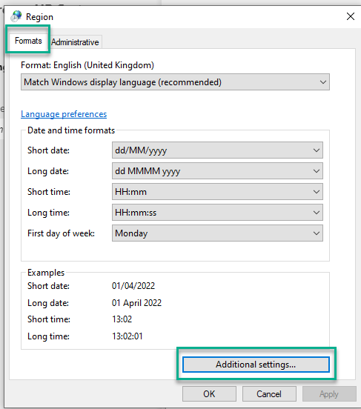

  - Click on Additional Settings on the Numbers or Format tab.

In the 'List Separator field' choose a pipe (|).

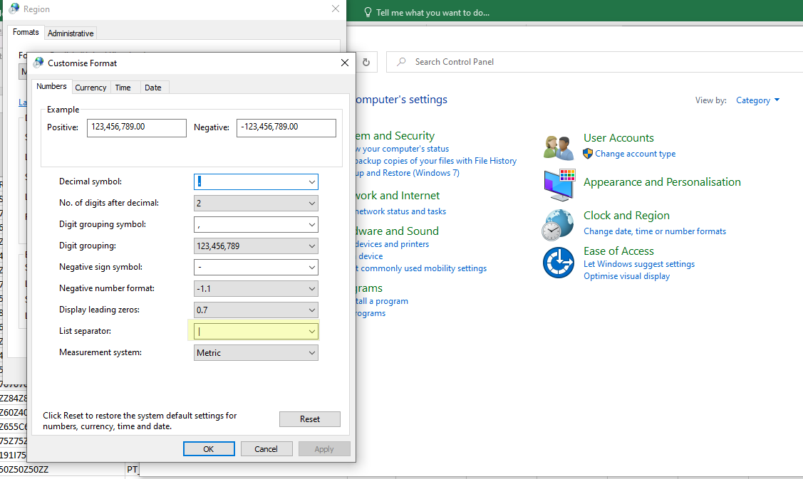
  - Save the document as a .CSV file. The shift code can be used as the filename, but remove the hyphen, as the PeopleXD DM tool doesn’t accept non alphanumeric characters in file names. Ensure you do not save again when closing the file in excel.

  - Open the document in Notepad++

  - Check the format of the file to ensure there are no odd gaps or characters

  - Save the file if you make any changes.

 | NB: Once you have finished editing the file you can change the list separator back.

Administrator dashboard > Data Migration > Data Migration Options

  - Click the ‘Load File’ button

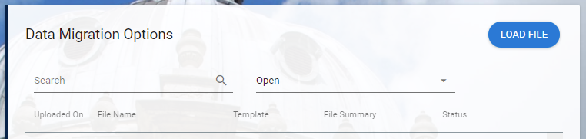

  - Click to upload - or drag and drop - the file you have prepared and click ‘OK’

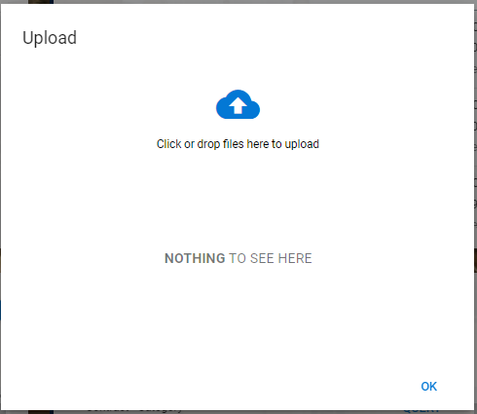

  - The system will scan the file for errors and display the data that will be entered into the system

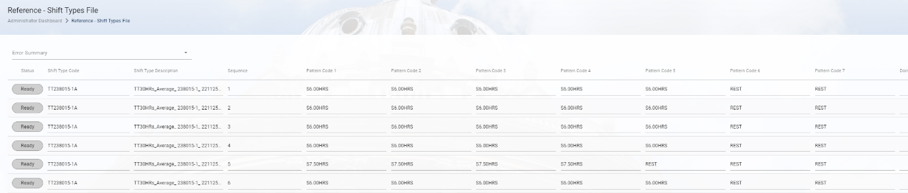

  - If no errors have been identified, click on the ‘Process All Records’ button in the bottom left corner.

 | NB: if processing multiple single-sequence shifts via the DM tool, you can select individual records without errors and process these individually. If you encounter errors with a multi-sequence shift it is advisable to update the source file and upload it again

  - The file status should change from ‘Ready’ to ‘Processing’ then to ‘Complete’.

Naming convention for complex shifts

Shift Type Code

Term-Time Only shift type codes follow the format:

TT<APP. ID><VERSION LETTER>

For example - TT15432-1B

Shift Type Description

Term-Time only shifts should follow the format:

TT##.##HRS <APP.ID> <PERSONNEL No.> <VERSION LETTER>

If the number of hours differs each week, you can insert the word average.
TT##.##HRS Average <APP.ID> <PERSONNEL No.> <VERSION LETTER>

